**DIGI-TECH E-COMMERCE WEBSITE**

20IT113

**SHIV PATEL**  
*Department of Information Technology  
C S Patel Institute of Technology, CHARUSAT*Changa, India  
20it113@charusat.edu.in

20IT119

**HONEY RAI***Department of Information Technology  
C S Patel Institute of Technology, CHARUSAT*Changa, India  
20it119@charusat.edu.in

20IT120

**JIMMY RAMANI***Department of Information Technology  
C S Patel Institute of Technology, CHARUSAT*Changa, India  
20IT120@charusat.edu.in

**Acknowledgments:** Many thanks to the Collage C S Patel Institute of Technology, CHARUSAT for giving me the opportunity to write a Research Paper on My Project.

Thanks also to Mr. SANKET SUTHAR for leading me through all the sections of this research paper. Without his support it would have been very difficult for me to prepare a meaningful and interesting paper.

With this research paper I learned a lot about Different programming languages like C,C++,JAVA,CSS etc.

Abstract :- Recent studies confirm that nowadays peoples are diverted towards the online shopping infact most of things are available online that peoples did’nt wish to go out and buy a product. The purpose of this project is to make the people’s life more Luxurious and can do an electronics items shopping by simply sitting at home. E-commerce (electronic commerce) is the activity of [electronically](https://en.wikipedia.org/wiki/Electronically) buying or selling of [products](https://en.wikipedia.org/wiki/Product_(business)) on online services or over the [Internet](https://en.wikipedia.org/wiki/Internet). E-commerce draws on technologies such as [mobile commerce](https://en.wikipedia.org/wiki/Mobile_commerce), [electronic funds transfer](https://en.wikipedia.org/wiki/Electronic_funds_transfer), [supply chain management](https://en.wikipedia.org/wiki/Supply_chain_management), [Internet marketing](https://en.wikipedia.org/wiki/Online_advertising), [online transaction processing](https://en.wikipedia.org/wiki/Online_transaction_processing), [electronic data interchange](https://en.wikipedia.org/wiki/Electronic_data_interchange) (EDI), [inventory management systems](https://en.wikipedia.org/wiki/Inventory_management_software), and automated [data collection](https://en.wikipedia.org/wiki/Data_collection) systems. It is often confusing to decide which electronic product to buy so, there are plenty of categories in website so that the people can decide more conviently.E-commerce typically uses the [web](https://en.wikipedia.org/wiki/World_Wide_Web) for at least a part of a transaction's life cycle although it may also use other technologies such as [e-mail](https://en.wikipedia.org/wiki/Email). All publicly accessible websites collectively constitute the [World Wide Web](https://en.wikipedia.org/wiki/World_Wide_Web). There are also private websites that can only be accessed on a [private network](https://en.wikipedia.org/wiki/Intranet), such as a company's internal website for its employees.Websites can be the work of an individual, a business or other organization, and are typically dedicated to a particulartopic orpurpose. To build this website, we use differentprogramming language like C,HTML,CSS etc... This website is user-friendly.

Keywords:-E-commerce,Electronically, Recommendation, Programming.

# **Introduction**

* A website (also written as web site) is a collection of [web pages](https://en.wikipedia.org/wiki/Web_page) and related content that is identified by a common [domain name](https://en.wikipedia.org/wiki/Domain_name) and published on at least one [web server](https://en.wikipedia.org/wiki/Web_server). Notable examples are [wikipedia.org](https://en.wikipedia.org/wiki/Wikipedia), [google.com](https://en.wikipedia.org/wiki/Google), and [amazon.com](https://en.wikipedia.org/wiki/Amazon_(company)). similarly, we have prepared website which is named as “DIGI-TECH” which is a website where people can buy the electronics products at their budgets at most convienient prices.We are making a system where people can buye-commerce computers item.
* It will contain all the necessary information like taking customers information for providing any ours information in future,customers interest items , proper invoices with taxes via online to both system and customers. In future we will also provide other e-commerce items with certain facilities.
* It is online buying e-commerce products with interesting Design and easily accessible.

These days we have grown with advanced technology.Websites can be used in various fashions: a personal website, a corporate website for a company, a government website, an organization website, etc. Websites can be the work of an individual, a business or other organization, and are typically dedicated to a particular topic or purpose. Many e-commerce websites come with many functions such as AI (Artificial Intelligence), action, bedtime, songs, playback and much more. This E-commerce website is randomly similar to closed but here we have come up with a website which deals with the new products which having the festivals discounts and also have the quiz for lucky draw winners there are many new offers. Websites are typically dedicated to a particular topic or purpose, such as news, education, commerce,entertainment, or [socialnetworking](https://en.wikipedia.org/wiki/Social_networking). [Hyperlinking](https://en.wikipedia.org/wiki/Hyperlink) between web pages guides the navigation of the site, which often starts with a [home page](https://en.wikipedia.org/wiki/Home_page).And in this project we are studying various programming languages which aregoing to use in it and also the back end which is the main backbone of the website.[Users](https://en.wikipedia.org/wiki/User_(computing)) can access websites on a range of devices, including [desktops](https://en.wikipedia.org/wiki/Desktop_computer), [laptops](https://en.wikipedia.org/wiki/Laptop), [tablets](https://en.wikipedia.org/wiki/Tablet_computer), and [smartphones](https://en.wikipedia.org/wiki/Smartphone). The [app](https://en.wikipedia.org/wiki/Application_software) used on these devices is called a [web browser](https://en.wikipedia.org/wiki/Web_browser).

# **Motivation & Problem statement**

Our E-commerce website name is “DIGI-TECH” by mean it has various categories of electronics items to buy.TheCustomer can Login if he/she wish to login the page.Here After Opening the Website You can see the Homepage which pop up with the Diwali sale offers then it has options of various categories of the electronics items.

We have to deal with a lot of problems before using thiswebsite because working with the programming language and learning it and applying it but some of the problems were faced in it due to complexity of the project. S till the backend of thewebsites is sodifficult to address it so we all are learning it assoon as possible sowe cancomplete this in upcoming time.

**1.Main Menu :**

This section outlines the design and implementation phase of the program. “DIGI-TECH E-Commerce website”isavailable in a web browser of the device, where the Customerr can take a part in lucky draw,can access various offers during festivals etc…

**2. Login / SignUp Category :**

In our website the signup/login is not compulsory but if the Customer wants to buy product second time then our website gives the discount to the regular Customer so while proceeding for payments while buying electronic product they must login the page for their intrest of profit.

**3.Add To Cart :**

Now If customer signup/login or not after that Customer can select the type of Electronics Appliances that Which type of product does Customer Wants to Buy.If Any Customer Likes the product and wants to save It for later to decide to buy then he/she can put that particular product to the ADD to Cart.

**4. Intresting Offers:**

As Diwali Festival is going on so Our website has Arranged the sale for the Customer and also there is a Lucky draw from which the Customer can give the QUIZ and wait to Announce the result of that and when the web will declare the result then that winner will get the rewards from our website.

**5. Display Category :**

Here,when the Customer open the website then by default it goes to the Home menu and there it has 4 options in which Customer can click. There are shop where there are plenty of categories which Customer can select then, blog of our website then comes the contact us where Customer can send us the problem faced by them and last there is a menu of Festival quiz which is already discussed above.

Currently, the website is about the Shopping the electronics items where there are different categories of multi compnies and different brands are available which the Customer can buy the products.The multi choice products without categories are displayed in the home menu where there are upcoming or latest products are displayed there.Some websites require user registration or [subscription](https://en.wikipedia.org/wiki/Subscription) to access content. Examples of [subscription websites](https://en.wikipedia.org/wiki/Paywall) include many business sites, news websites, [academic journal](https://en.wikipedia.org/wiki/Academic_journal) websites, gaming websites, file-sharing websites, [message boards](https://en.wikipedia.org/wiki/Internet_forum), web-based [email](https://en.wikipedia.org/wiki/Email), [social networking](https://en.wikipedia.org/wiki/Social_networking) websites, websites providing real-time [stock market](https://en.wikipedia.org/wiki/Stock_market) data, as well as sites providing various other services.

Whenthe Customer like the product and wanted to know the features of that particular product than the user can click on that product than the product will open with the quality and its features used in it.If the Customer face any of the difficulty then they can contact us by going into the contact menu and send the message which they faced during using our DIGI TECH.Some websites may be included in one or more of these categories. For example, a business website may promote the business's products, but may alsohost informativedocuments, such as [white papers](https://en.wikipedia.org/wiki/White_paper).

ADVANTAGES :

* Now a days people mostly prefer online shopping.So this web site will be use full to them.
* Customer can buy their likely product from their comfort zone.
* This may savecustomer time efforts.
* In our website upcoming electronic appliances will be available for purchase in advance.
* Customer gets Wide range of products are available.
* Customer also gets detailed information about the product.
* Customer also gets good discounts on special offersand can buy his/her required electronic item in lower prices.
* Generally, in physical stores, the sales representatives try to influence the buyers to buy the product. While in online shopping, you're free to do as you will.

MAJOR REQUIRMENTS

The major requirement that are required for the websites are….

**In Software:**

**HTML , CSS , JAVA SCRIPT, DRIVE , GITHUB**

**In Hardware:**

**LAPTOP , MOBILE (FOR CREATING & TESTING THE WEBSITE)**

RESULT:

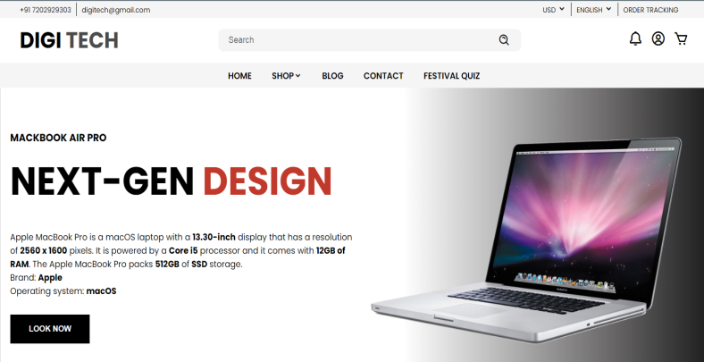

This image is the homepage of the website. It shows the name of our project website that is “DIGI-TEC”. It contains different options such as shop, blog, contact, festival quiz etc.

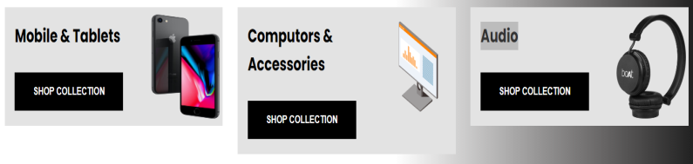

Now when the customer scroll down from the home page he will find this. In this all kind of electronic appliances as shown with their collections.

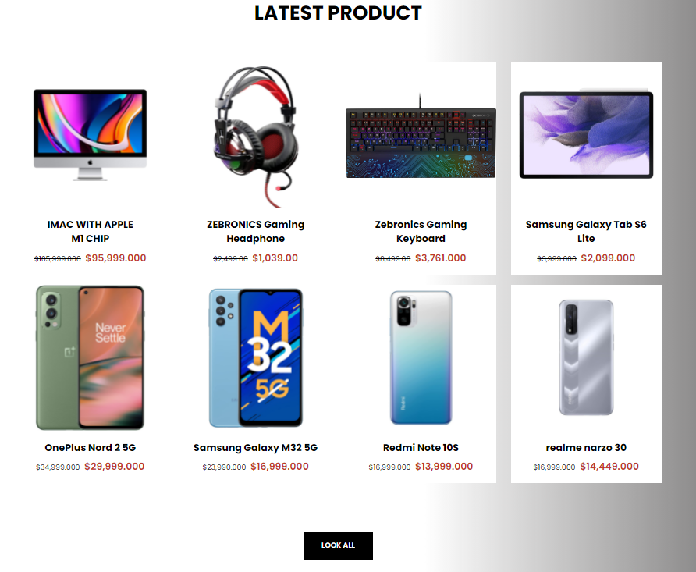

Now while scrolling down all the latest products that are available in the market are shown with their name and price. It also has an option of **LOOK ALL**. By this option customer can see all the latest product.

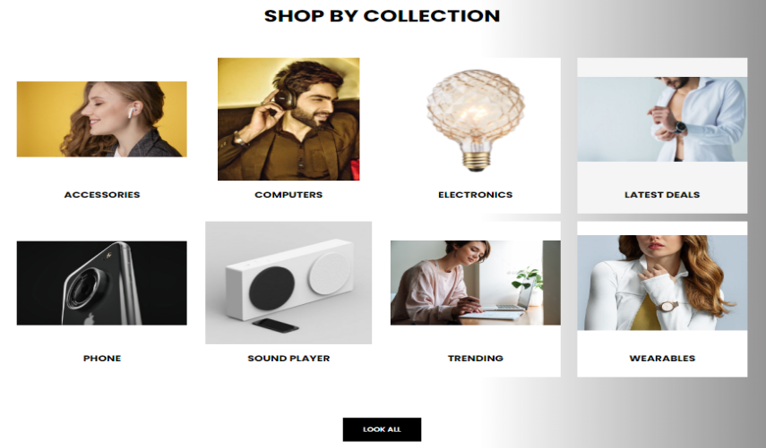

Now on this page it displays different options of electronic items such as electronic accessories i.e air pods , wearable items such as watches , all the trending items, latest deals etc.

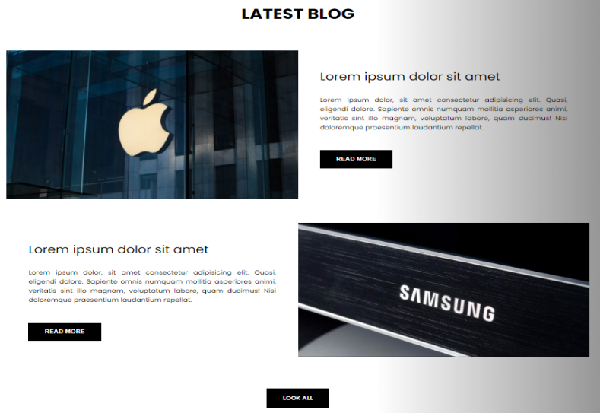

This website also has a page in which blogs of different companies that are trending in the field of electronics is given. Customer may get knowledge from here.

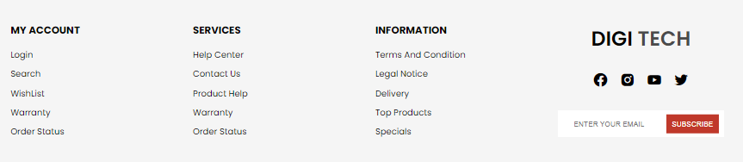

At the end of our website the customer is given different options. Customer can create her account on this website. She can search different appliances over here. She can see her order status. She can get information about this website and she can contact with the owner’s of this website.

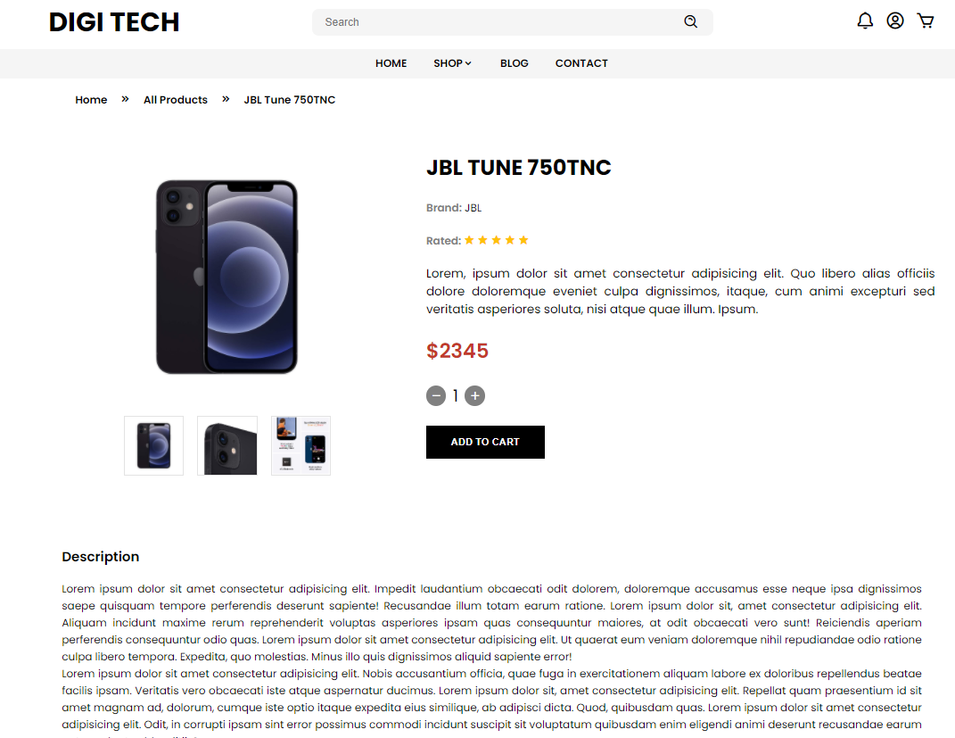

When the customer clicks on a particular item this kind of page will be appeared. In this page the complete information and price of that electronic device is given. The page also shows the image of that product.

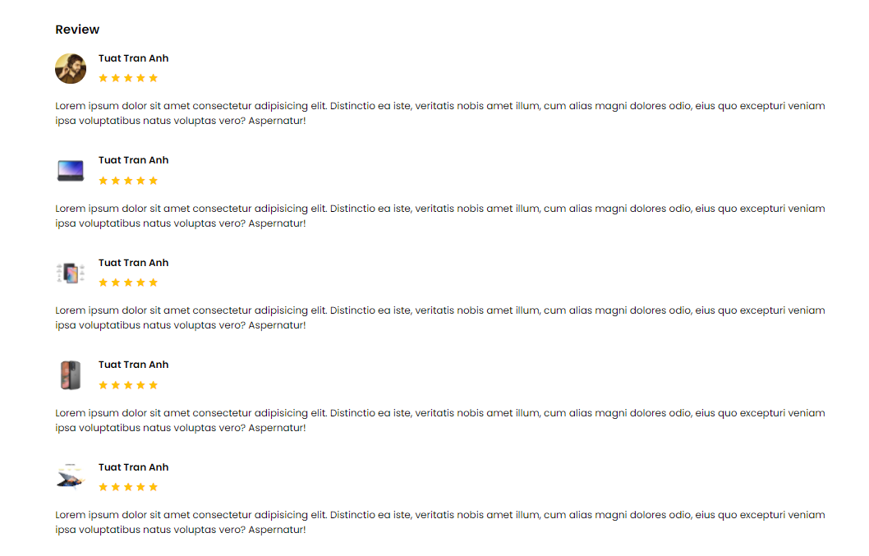

Here the customer is also given so that he can see the review of the product. By seeing the review customer will have the proper idea of the product.

CONCLUSION:

In this project we have developed an e-commerce

website which is helpful in online shopping of

different electronics appliances such as mobile,

laptops, headphones etc. This website will be very

easy to access. And it also contains detailed

information of the given products.The customer

also gets advantage of different discounts on special

offers such as festivals etc.

REFERENCES:

* Burgstahle, Sheryl. Universal Design in
* Higher Education: From Principles to Practice, Harvard Education Press, 2008.
* Byrne, Jim. 60 hot to touch Accessible Web Design tips – the tips no web developer can live without!, Jim Byrne, 2006, (ISBN: 978-1-4116-6729-7).
* Coolidge, Doner, Robertson, and Gray. [ccessibility Toolkit - 2nd Edition](https://opentextbc.ca/accessibilitytoolkit/), BCcmpus, 2020.
* Digital Education Strategies, The Chang Schol. [What You Can Do to Remove Barriers o the Web](https://pressbooks.library.ryerson.ca/a11ygame/), The Chang School, 2020.